Assignment 7

Q 1 :  
Explore the relationship between the following, where x contains numbers

from 1 to 100:

1. x and x^2

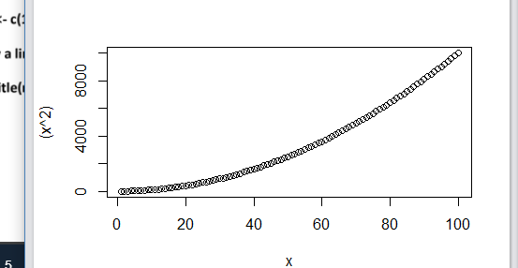

1. x and x^3  
   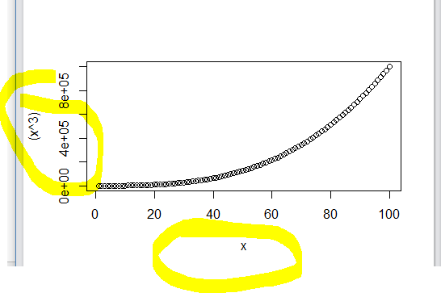
2. x + y = 101

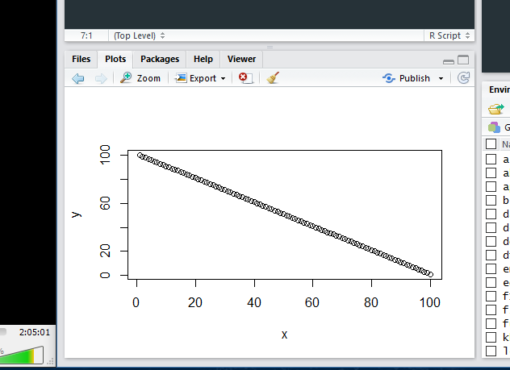

D) xy = 500  
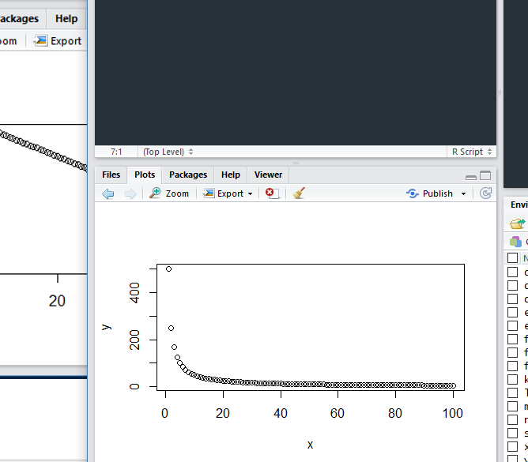

2. First we'll produce a very simple graph using the values in the car vector:

# Define the cars vector with 5 values cars <- c(1, 3, 6, 4, 9)

# Graph the cars vector with all defaults plot(cars)

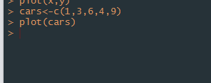

Let's add a title, a line to connect the points, and some color:

# Define the cars vector with 5 values cars <- c(1, 3, 6,

# Graph cars using blue points overlayed by a line plot(cars, type="o", col="blue")



Output

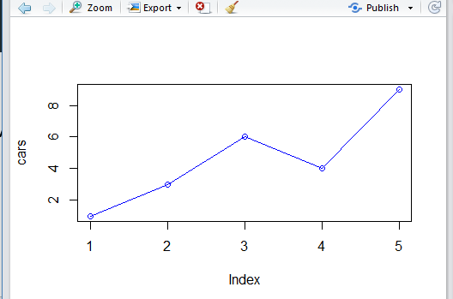

# Create a title with a red, bold/italic font title(main="Autos", col.main="red", font.main=4)

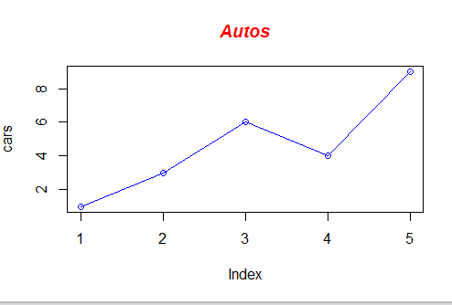

• Now let's add a red line for trucks and specify the y-axis range directly so it will be large enough

to fit the truck data:

• # Define 2 vectors cars <- c(1, 3, 6, 4, 9) trucks <- c(2, 5, 4, 5, 12)

• # Graph cars using a y axis that ranges from 0 to 12 plot(cars, type="o", col="blue",

ylim=c(0,12)

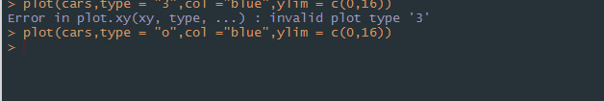

Output

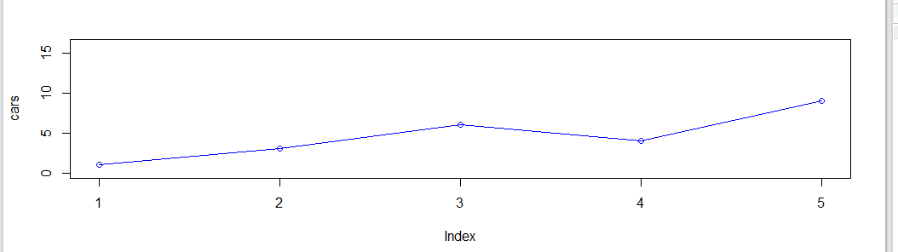

• # Graph trucks with red dashed line and square points lines(trucks, type="o", pch=22,

lty=2, col="red")

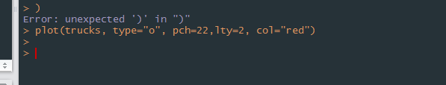  
Output

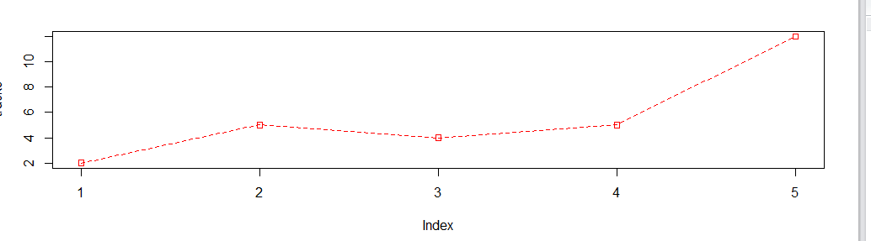

# Create a title with a red, bold/italic font title(main="Autos", col.main="red",

font.main=4)

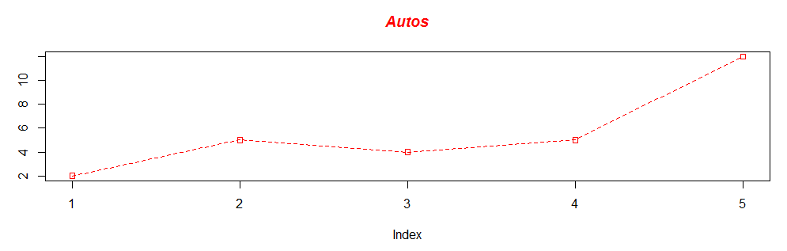

All code:

